Technical Proposal
Enterprise Corporate Website Development (From Scratch)

Prepared By: Riseup Labs


1. Executive Summary
This proposal outlines the approach to design and develop a modern, secure, and scalable corporate website from scratch, aligned with enterprise brand standards and optimised for user experience, SEO, performance, and security. The solution will include a responsive public website, a role-based content management capability, content governance workflows, and integrations for analytics and lead capture.

2. Understanding of Requirements
Based on the provided scope documents, the target website must provide:
- Enterprise-grade corporate web presence with modern UX/UI and responsive design.
- Clear information architecture and consistent page templates for services, insights, leadership, and careers.
- Structured services and sub-services pages (5 to 10 sub-offerings per primary service line).
- Industry vertical pages with tailored content and case studies.
- Insights/Knowledge Hub with search, tagging, and filters.
- Content personalisation based on user industry, role, and behaviour.
- Recommendation system support for Insights / Knowledge Hub pages.
- Events/Webinars section with calendar, registration, and post-event assets.
- Contact and office locations with enquiry forms and map views.
- Strong performance, security, privacy, accessibility, and cookie compliance.
- Content governance with role-based approvals and auditability.

3. Proposed Solution Overview
We propose an API-first, modular architecture using a full-stack Next.js (TypeScript) platform, a secure headless CMS, and PostgreSQL with pgvector for unified relational and vector-enabled data management. This enables fast page delivery, strong SEO, long-term scalability, and efficient content operations through workflow-based publishing.

Figure 1: High-Level Solution Architecture
Public users access a full-stack Next.js (TypeScript) web platform protected by CDN and WAF. The platform uses the Next.js API layer for backend services, a headless CMS such as Sanity or Payload CMS or Strapi for editorial operations, PostgreSQL with pgvector for relational data and vector-enabled, and secure object storage for media assets.
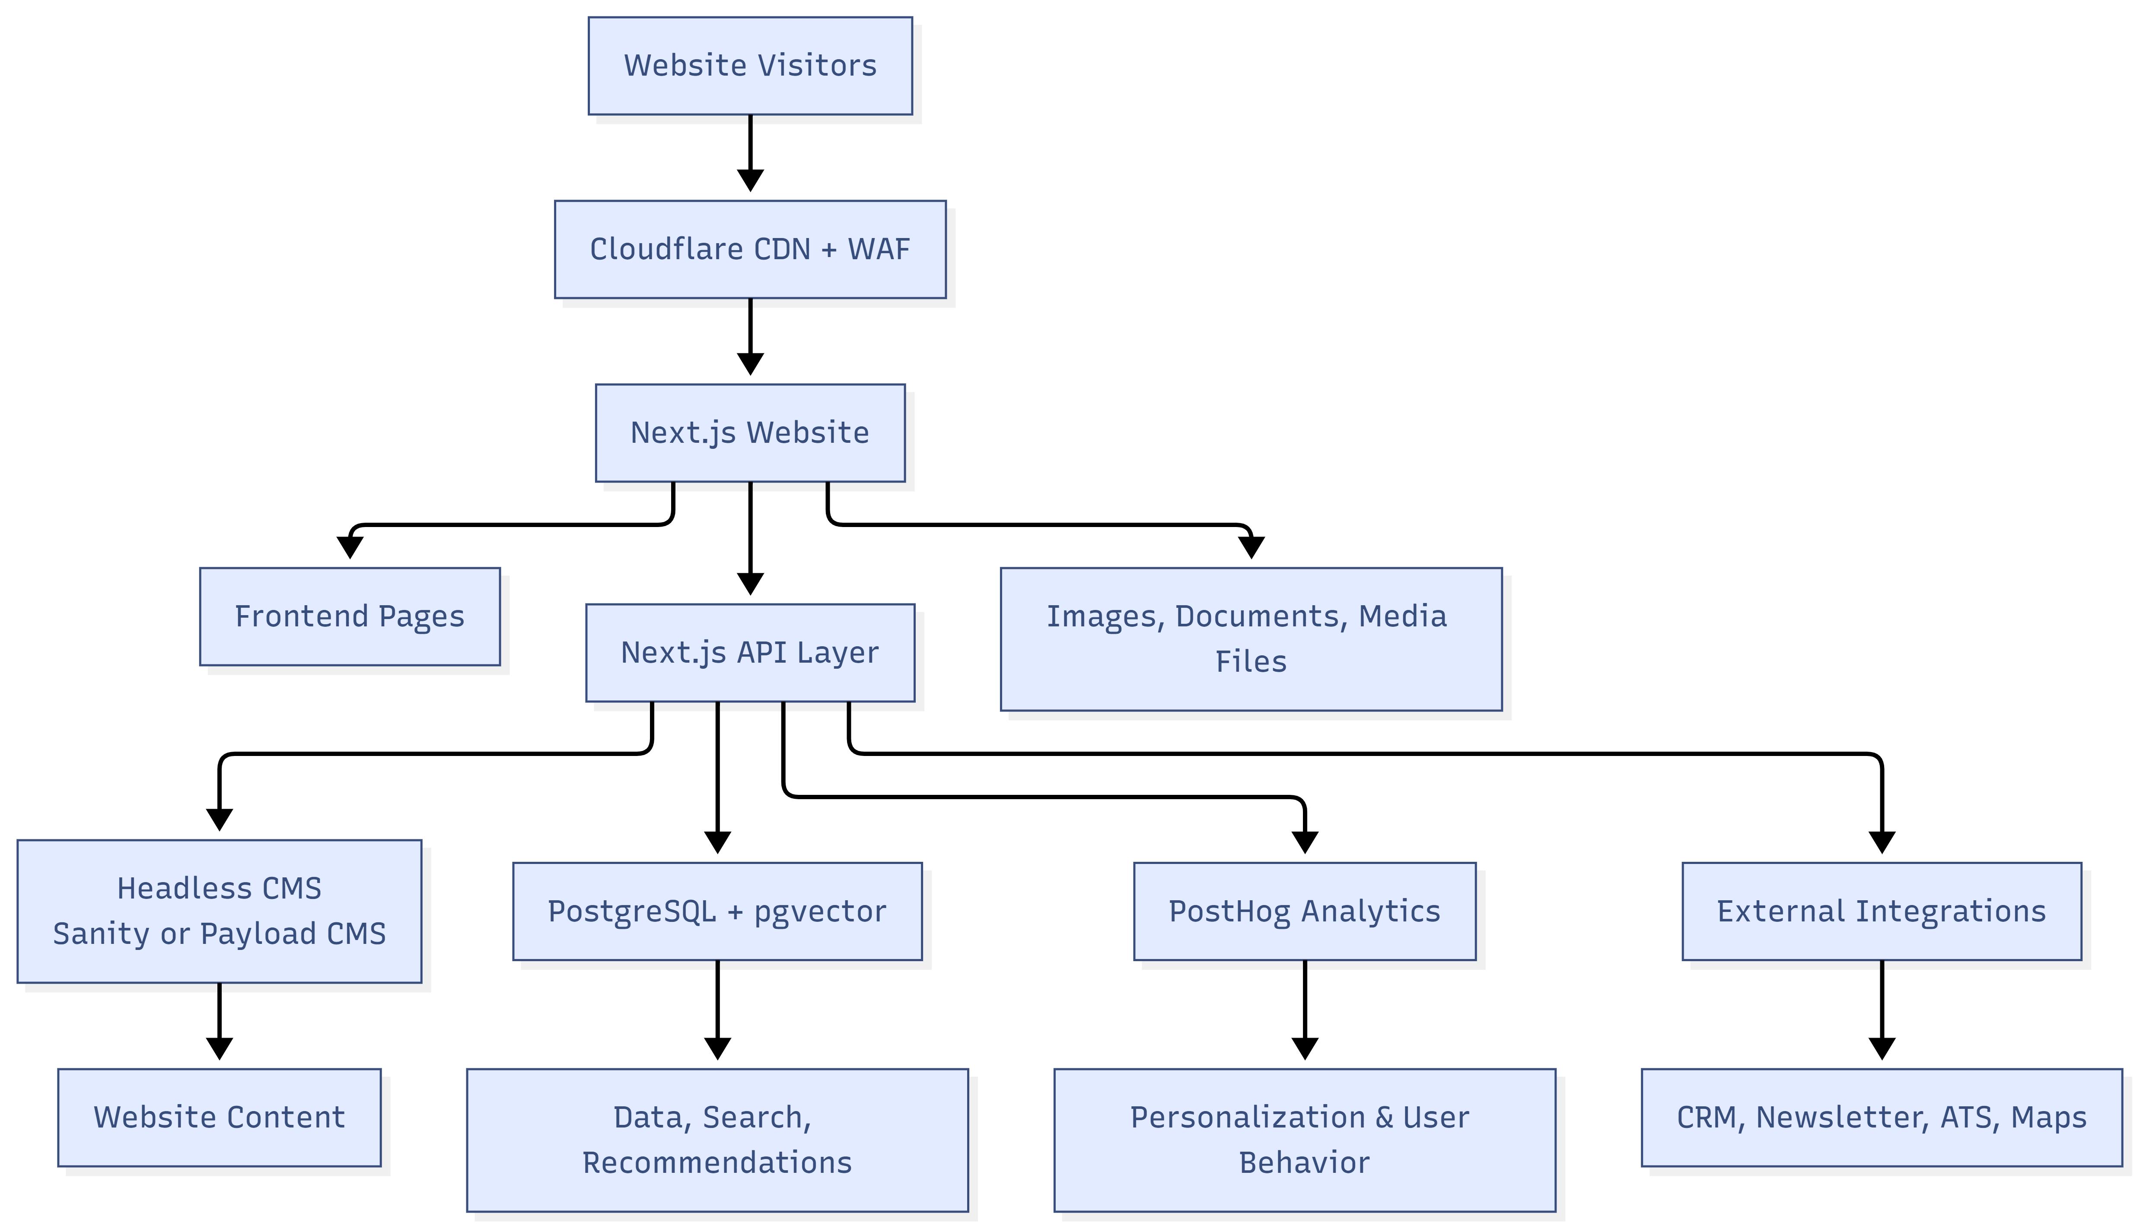

4. Scope of Work

4.1 Website Modules and Pages
The website will be developed using reusable page templates. Core sections include:

A. Homepage
- Hero section with dynamic content blocks.
- Quick navigation to Services, Insights, Industries.
- Client/partner logos section.
- Strategic calls-to-action (Talk to us, Request a meeting, Subscribe).

B. About KPMG
- Company overview
- Values, vision, mission
- Leadership profiles

C. Services
- Primary service line pages: Audit, Tax, Advisory, Consulting, Digital/Technology, ESG and Sustainability, Risk and Compliance.
- Sub-service pages under each primary service line (estimated 5 to 10 per category).
- Case highlights and lead capture sections.

D. Industry Verticals
- Sector pages such as Financial Services, Healthcare, Government/Public Sector, Energy and Utilities, Technology and Digital, Consumer Markets.
- Tailored content and case study blocks per industry.

E. Insights / Knowledge Hub
- Content types: articles, publications, reports, thought leadership.
- Search with tagging and filters (topic, industry, date).
- Share metadata support.

F. Events / Webinars
- Event calendar and listings.
- Event detail pages.
- Registration forms and attendee export.
- Post-event assets (slides, video links, documents).

G. Careers
- Jobs listing and detail pages
- Application links or application forms.

H. Contact / Office Locations
- General enquiry form.
- Office locations list by region.
- Map and directions.

4.2 Content Management and Governance
A secure headless CMS admin portal will be configured to manage content and publishing operations. Instead of building a custom CMS from scratch, a headless CMS such as Sanity or Payload CMS is recommended to support faster delivery, better security, and a smoother editorial experience, including:
- Role-based access control (Admin, Editor, Reviewer, Publisher).
- Draft, review, approve, publish workflow with audit log.
- Reusable templates for pages, service entries, insight posts, leadership profiles, careers, and events.
- Media library with versioned uploads and optimised web formats.

Figure 2: Content Governance Workflow

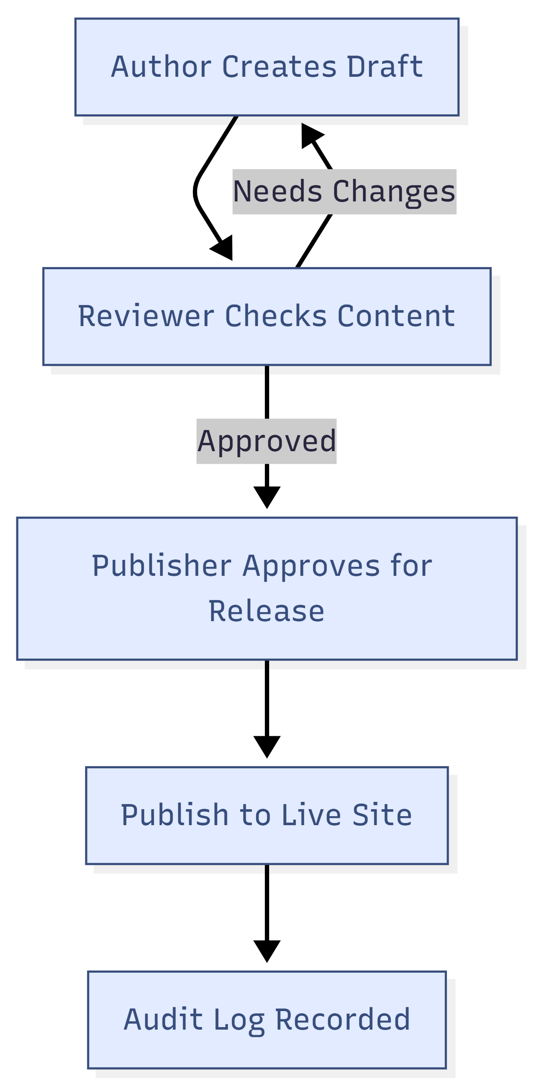

4.3 UI/UX and Asset Development (In Scope)
UI/UX and digital asset development are included. Design work will align with global brand guidelines and will include:
- Discovery workshops and user journey definition for key audiences.
- Information architecture, sitemap, and wireframes for all templates.
- High-fidelity responsive UI designs (desktop, tablet, mobile).
- Design system and reusable component library for consistent implementation.
- Asset creation and optimisation: icons, illustrations, image treatments, and web-ready exports.

4.4 Integrations (As Required)
The platform will support common enterprise integrations, including:
- Analytics: Google Analytics 4 and Google Tag Manager.
- Product analytics and behavioural insights: PostHog for event tracking, segmentation, experiments, and feature flag-based content variations.
- Content personalisation: personalised content blocks based on user industry, role, and on-site behavior.
- Email marketing: newsletter signup via Mailchimp or corporate distribution tools.
- Careers: applicant tracking system integration (ATS) or external job portal links.
- Social: social links, sharing metadata, and structured preview cards.
- Newsletter integration with Mailer lite
- Smtp integration with Smpt2go or equivalent
- Ai Chatbot integration

5. Proposed Technical Stack
Layer | Proposed Technology | Notes
Frontend | Next.js (React + TypeScript) | Server-side rendering, static generation, responsive UI, and SEO-focused page delivery.
Backend / API Layer | Full-stack Next.js (TypeScript) API layer | Route handlers/server-side services for APIs, integrations, form handling, workflow integration, and secure business logic.
CMS | Headless CMS (Sanity or Payload CMS or Strapi) | Configured editorial admin, content models, roles, approval workflow, previews, and media governance without building a custom CMS from scratch.
Database | PostgreSQL + pgvector extension | Unified relational and vector-enabled data store for content, users, audit logs, configuration, embeddings, and recommendation/search data.
CDN and Security | Cloudflare CDN + WAF | Edge caching, DDoS protection, WAF rules and bot mitigation.
Search and Recommendations | PostgreSQL full-text search + pgvector vector search with HNSW indexing | Keyword search, filters, semantic matching, and Insights / Knowledge Hub recommendations without a separate vector database.
Analytics and Personalisation | PostHog + Google Analytics 4 + Google Tag Manager | Behaviour tracking, segmentation, experiments, feature flags, and content personalisation based on industry, role, and behaviour.
Media Storage | Object storage (S3 compatible) + CDN | Optimised images, documents, and event assets.
CI/CD | Git-based CI pipeline | Automated build, test, and deployment to staging and production.
Monitoring | Uptime monitoring + error tracking | Operational visibility, alerting, and incident response.

6. Development Methodology and Approach
We will follow an iterative delivery model with clear milestones, stakeholder checkpoints, and continuous quality assurance. The approach is aligned with the recommended roadmap: Discovery and Architecture, Design and Content Model, Development, Integration and Migration, Testing and Tuning, Launch and Stabilisation.

6.1 Discovery and Architecture
- Stakeholder workshops and requirement validation.
- Information architecture and navigation structure finalisation.
- Non-functional requirements definition (performance, security, accessibility, SEO).
- Solution architecture and environment planning.
Key deliverables:
- Requirement specification and sitemap.
- Architecture definition (high-level and component level).
- Initial content inventory and migration plan (if applicable).

6.2 UX/UI and Content Model
- Wireframes for key templates and user flows.
- UI design aligned with brand guidelines and responsive breakpoints.
- Headless CMS content model definition for pages, services, industries, insights, events, leadership, careers, and locations.
- Design system components and handoff assets.
Key deliverables:
- Approved UI screens and reusable components.
- Content model and CMS field definitions.
- Asset pack for development.

6.3 Development
- Frontend development for public site templates and components.
- Full-stack Next.js API layer development for APIs, server-side logic, integrations, RBAC support, workflow integration, and audit logging.
- Implementation of search, tagging, filters, and structured content listing pages.
- Implementation of content personalisation and Insights / Knowledge Hub recommendation logic using PostHog behavioural signals and PostgreSQL/pgvector where applicable.
- Headless CMS configuration for editorial roles, content models, approvals, previews, and publishing workflows.
- Form handling with validation, rate limiting, and CRM routing if required.
- Media handling and optimisation pipeline.
Key deliverables:
- Working staging environment with full website templates.
- Configured headless CMS admin portal and editorial workflows.
- Integrated analytics and tracking setup.

6.4 Integration and Content Migration (If Applicable)
- Integrate ATS, newsletter, CRM, and other third-party tools as agreed.
- Content migration support (manual import tools, batch upload, and QA).
- Redirect mapping and SEO preservation for migrated content.
Key deliverables:
- Integrated services and validated data flows.
- Migration checklist and sign-off.

6.5 Testing and Tuning
- Full QA cycle: functional, regression, and cross-browser tests.
- Performance optimisation and Core Web Vitals tuning.
- Security hardening: WAF rules, secure headers, vulnerability checks.
- Accessibility checks and remediation.

Key deliverables:
- QA sign-off report with test evidence.
- Performance and security readiness checklist.

6.6 Launch and Stabilization
- QA support and fixes.
- Production deployment and go-live execution plan.
- Post-launch monitoring and stabilisation support.
- Handover: documentation and knowledge transfer.
Key deliverables:
- Go-live checklist and rollback plan.
- Operational runbook and admin guide.

7. Security, Performance, SEO, and Compliance

7.1 Security Controls
- CDN and WAF at the edge for threat mitigation and DDoS protection.
- TLS encryption, secure HTTP headers, and strict input validation.
- Role-based access control for admin portal and content workflows.
- Audit logging for content changes, approvals, and administrative actions.
- Rate limiting and bot protection for public forms.

7.2 Performance Optimisation
- Next.js SSR, static generation, route handlers, and caching for fast content delivery.
- Cloudflare caching strategy for global edge performance.
- Image optimisation, lazy loading, and responsive media delivery.
- PostgreSQL indexing, pgvector HNSW indexing for vector search, query optimisation, and caching for high-traffic pages.

7.2.1 Measurable Performance and Responsiveness Targets
The following measurable targets will be used during QA and launch readiness validation, subject to final hosting capacity, production content volume, and third-party integration response time:

Area | Target Metric | Validation Method
Website Performance | Key public pages should load within 3 seconds under normal conditions. | Check using Lighthouse or PageSpeed Insights.
Lighthouse Score | Target score of 80+ for main pages after content and hosting setup. | Test homepage, service page, insights page, and contact page.
API Responsiveness | Common APIs should respond within 1 second under normal usage. | API monitoring and response time checking.
Search and Recommendations | Search and recommendation results should load within 1 to 2 seconds. | Test search and recommendation features with sample content.
Responsive Layout | Website should work properly on mobile, tablet, and desktop screens without layout issues. | Manual responsive testing on common screen sizes.
Load Readiness | Website should support normal visitor traffic smoothly during launch. | Basic load testing for browsing search, forms, and event registration.

7.3 SEO and Content Structure
- SEO-friendly URLs and content templates with consistent heading hierarchy.

7.4 Privacy, Accessibility, and Compliance
- Cookie notice, privacy policy hooks, and consent-based tracking configuration.
- Accessibility aligned to common corporate expectations (keyboard navigation, contrast, alt text, ARIA labels).
- Secure data handling for enquiry and registration forms.

Figure 3: Multi-Layer Security Model
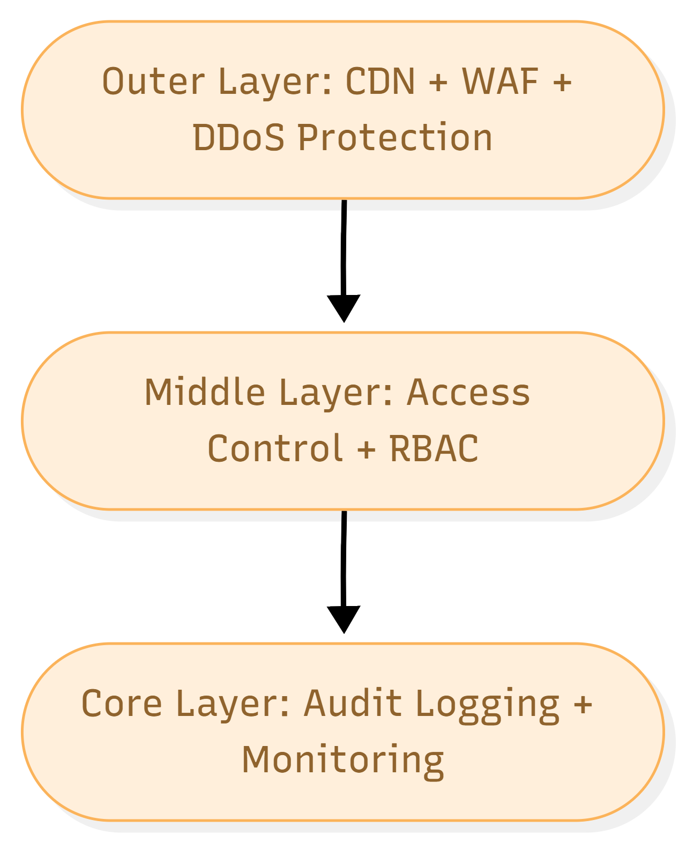

8. Testing and Quality Assurance
Quality assurance will be embedded throughout delivery. The testing strategy includes:

8.1 Test Types
- Testing for backend services and critical frontend utilities.
- Integration testing for APIs, forms, and third-party integrations.
- End-to-end testing for critical user journeys (navigation, search, enquiry, event registration).
- Cross-browser and responsive testing across common devices and screen sizes.
- Accessibility testing with automated checks and manual verification.
- Performance testing using Lighthouse metrics, Core Web Vitals, responsiveness checks, and load testing against the agreed performance targets.
- Security testing includes OWASP-aligned checks, dependency scanning, and basic penetration testing support.

Fig: QA Test Process

9. Deployment and Operations
We will set up separate environments to reduce risk and ensure controlled releases.
- Environments: Development, Staging, Production.
- Automated deployments via CI pipeline with approvals for production.
- Backups and restore procedures for database and media storage.
- Monitoring, logging, and alerting for application health and security events.

10. Deliverables Summary
The key deliverables of this engagement include:
- Project initiation and requirement specification documents.
- Information architecture, sitemap, and UX wireframes.
- High-fidelity UI designs, design system, and asset pack.
- Fully developed responsive website (frontend and backend) from scratch.
- Configured headless CMS with RBAC, workflows, and audit logs.
- Search, tagging, filters, recommendation logic, and content templates for insights and events.
- Integrations: analytics, PostHog-based behavioural insights, newsletter, ATS/CRM (as agreed).
- Testing deliverables: test plan, test reports, QA support, release checklist.
- Deployment artefacts: CI/CD configuration, runbook, and handover documentation.

11. Assumptions, Dependencies, and Exclusions

11.1 Assumptions
- Client will provide brand guidelines, content owners, and timely approvals.
- Required access to domains, DNS, hosting accounts, and integration endpoints will be provided.
- Content volumes and migration needs will be confirmed during discovery.
- Client will confirm the preferred headless CMS option, such as Sanity or Payload CMS, during discovery.
- Client will provide or approve user industry, role, and content taxonomy rules required for personalisation and recommendations.

11.2 Dependencies
- Availability of stakeholders for workshops and reviews.
- Third-party vendors for ATS, CRM, email marketing, and analytics tools.
- Hosting and security policies required by the client organisation.

11.3 Exclusions (Unless Added by Change Request)
- Paid third-party licensing costs and subscriptions.
- Large-scale content creation beyond agreed templates and initial assets.
- Advanced AI assistant features, multi-country multisite capabilities, or complex marketing automation beyond the agreed personalisation and recommendation scope can be scoped later.

